Payen and Persoz discovered
A. Diastase
B. Lactase
C. Protease
D. Lipase
ANSWER: A
The biocatalysts which increase the chemical reaction are called:
A. Enzymes
B. Isomers
C. Reactants
D. Products
ANSWER: A
The nature of an enzyme is
A. Lipid
B. Vitamin
C. Carbohydrate
D. Protein
ANSWER: D
The site of enzyme where substrate is attached, called:
A. Non catalytic site
B. Active site
C. Medium site
D. Allosteric site
ANSWER: B
Enzymes are
A. Hormones
B. Biocatalysts
C. Inorganic substances
D. None of these
ANSWER: B
______________catalyzes the transformation of the substrate into products
A. Binding Site
B. Catalytic Site
C. Allosteric Site
D. None of these
ANSWER: B
__________ are enzymes consists of RNA and are found in ribosomes.
A. Prosthetic group
B. Co-factor
C. Ribozymes
D. None of these
ANSWER: C
Biological molecules (proteins) which catalyze a biochemical reaction and remain unchanged after completion of the reaction are called
A. Cofactor
B. Coenzymes
C. Activator
D. Enzymes
ANSWER: D
The protein part of holoenzyme is:
A. Apoenzyme
B. Lysozyme
C. Co-enzyme
D. Phytoenzyme
ANSWER: A
The non-protein part of an enzyme is:
A. Prosthetic group
B. Co-factor
C. Co-enzyme
D. All of these
ANSWER: D
Enzymes are generally
A. Fibrous proteins
B. Polysaccharides
C. Globular proteins
D. Acylglycerol
ANSWER: C
Payen and Persoz discovered
A. Diastase
B. Lactase
C. Protease
D. Lipase
ANSWER: A
Excessive increase in temperature of medium causes the enzyme molecule to____________?
A. Activate
B. Unaffected
C. Denatured
D. None of these
ANSWER: C
An activated enzyme consisting of polypeptide chain and a cofactor is called_______________?
A. Apoenzyme
B. Holoenzyme
C. Activated enzyme
D. Both b and c
ANSWER: D
The active site of an enzyme:
A. Never changes
B. Forms no chemical bond with substrate
C. Determined by structure and the specificity of the enzyme.
D. They are non-specific in their action
ANSWER: C
Which step causes activation of the catalytic site of an enzyme?
A. Change in pH of the surroundings
B. Formation of enzyme-substrate complex
C. Change in the charge of the active site
D. Change in temperature
ANSWER: B
ESC stands for:
A. Enzyme Substrate Complex
B. Energy Substrate Complex
C. Energy Synthesis Complex
D. Enzyme Synthesis Complex
ANSWER: A
Which statement is incorrect about the Lock and Key Model?
A. Specific enzyme can transform only a specific substrate
B. Active site of an enzyme is a non-flexible structure.
C. Active site does not change before during or even after the reaction.
D. It explains the mechanism of every chemical reaction
ANSWER: D
The term enzymes was proposed by:
A. Koshland
B. Margules
C. Robert
D. Kuhne
ANSWER: D
Induce fit model theory about the action of enzyme is proposed by:
A. Koshland
B. Fischer
C. Kuhn
D. Richard
ANSWER: A
The lock and key model was first postulated by:
A. Fischer
B. Daniel Koshland
C. Louis Pasture
D. Lamarck
ANSWER: A
The lock and key model was first postulated in:
A. 1894
B. 1954
C. 1654
D. 1548
ANSWER: A
The lock and key model explains that the enzyme and the substrate possess:
A. Different geometric shapes
B. Specific complementary geometric shapes
C. Opposite geometric shapes
D. None of these
ANSWER: B
Induced fit model suggested by:
A. Emil Fischer
B. Daniel Koshland
C. Louis Pasture
D. Lamarck
ANSWER: B
The induced fit model suggested by Daniel Koshland in
A. 1959
B. 1855
C. 1745
D. 1695
ANSWER: A
_______________explains that active site of enzyme continuously changes it shape until the substrate bind to it.
A. The lock and key model
B. Induced fit model
C. Fluid mosaic model
D. Rutherford model
ANSWER: B
To understand the mechanism of enzyme action _____________theories are proposed.
A. One
B. Two
C. Three
D. Four
ANSWER: B
According to the lock and key model, substrate is the:
A. Key
B. Key hole
C. Lock
D. None of these
ANSWER: A
According to the lock and key model, active site is the
A. Key
B. Key hole
C. Lock
D. None of these
ANSWER: B
According to the lock and key model, the enzyme act as the
A. Key
B. Key hole
C. Lock
D. None of these
ANSWER: C
Which step causes activation of the catalytic site of an enzyme?
A. Change in pH of the surroundings
B. Formation of enzyme-substrate complex
C. Change in the charge of the active site
D. Change in temperature
ANSWER: B
The reactants on which enzyme works are:
A. Product
B. Substrate
C. Metabolites
D. Catabolites
ANSWER: B
ESC stands for:
A. Enzyme Substrate Complex
B. Energy Substrate Complex
C. Energy Synthesis Complex
D. Enzyme Synthesis Complex
ANSWER: A
The enzyme catalyzes the reaction by:
A. Attaching to substrate
B. Removing the substrate
C. Liberating the product
D. None of these
ANSWER: A
Enzyme exposes its _______________to attract specific substrate
A. Active site
B. Non-catalytic site
C. ESC
D. All of these
ANSWER: A
After the _____________is formed and enzyme is detached from it and used again for the same reaction.
A. Product
B. Reactant
C. ESC
D. None of these
ANSWER: A
When ES complex breaks, it releases:
A. Enzyme
B. Product
C. Substrate
D. Both A and B
ANSWER: D
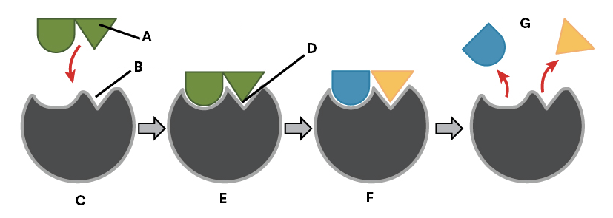

Observe the diagram and identify what structure A represents:
A. Product
B. Substrate
C. Enzyme
D. Active site
ANSWER: B
The Lock and key model was developed for the visualization of substrate and enzyme concentration was proposed by:
A. F. Sanger
B. Erwin Chargaff
C. Edward
D. Emil Fischer
ANSWER: D


Observe the diagram and identify what structure D represents:
A. Substrate entering the active site of the enzyme
B. Enzyme/substrate complex
C. Enzyme changes shape slightly as substrate binds
D. Products leaving the active site of the enzyme
ANSWER: C
The combination formed by an enzyme and its substrates is called the
A. EP complex
B. Enzyme–substrate complex
C. ES Complex
D. Both B and C
ANSWER: D


Observe the diagram and identify what structure C represents:
A. Substrate entering the active site of the enzyme
B. Enzyme/substrate complex
C. Enzyme changes shape slightly as substrate binds
D. Products leaving the active site of the enzyme
ANSWER: A
The target substrate molecules bind to active site of the enzyme transforming into products through a series of steps known as the:
A. Enzyme kinetics
B. Enzymatic mechanism
C. Chemical kinetics
D. Zero order reaction kinetics
ANSWER: B



Observe the diagram and identify what structure G represents:
A. Products
B. Substrate
C. Enzyme
D. Active site
ANSWER: A

Observe the diagram and identify what structure B represents:
A. Products
B. Substrate
C. Enzyme
D. Active site
ANSWER: D
Which step causes activation of the catalytic site of an enzyme?
A. Change in pH of the surroundings
B. Formation of enzyme-substrate complex
C. Change in the charge of the active site
D. Change in temperature
ANSWER: B
SSSSA three-dimensional cavity bearing a specific charge by which the enzyme reacts with its substrate is called
A. Active site
B. Binding site
C. Catalytic site
D. Allosteric site
ANSWER: A
____________ is defined as the minimum amount of extra energy required by a reacting molecule to get converted into product
A. Energy
B. Radiation energy
C. Activation energy
D. Solar energy
ANSWER: C
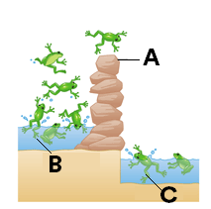
Which of the following represents A in the given diagram?
A. Activation energy barrier
B. Reactants
C. Products
D. All of these
ANSWER: A
Which of the following represents B in the given diagram?
A. Activation energy barrier
B. Reactants
C. Products
D. All of these
ANSWER: B
Which of the following represents C in the given diagram?
A. Activation energy barrier
B. Reactants
C. Products
D. All of these
ANSWER: C
Enzyme increases the chemical reactions by lowering the:
A. Non activation energy
B. Activation energy
C. Solar energy
D. Radiation energy
ANSWER: B

